# Augmented eBay Modified Charter

• Project Definition – This web/mobile application will enable eBay sellers to list items with rich text pictures, videos and files for free.

• Project Scope – Two applications

o Augmented eBay

o Augmented eBay Pro: access to device I/O and file manager (marked by *)

It empowers the seller to upload eBay listings with the aid of following features.

* Rich text description
* Ability to append more than 1 image (upto 20 or more*)for free by the following means
  + Image Url
  + Laptop / Phone /Tablet Gallery
  + Camera *
* Ability to append multiple videos
  + Upload *
  + Youtube URL
  + Laptop / Phone /Tablet Gallery
* Ability to upload files
  + Windows Skydive URL
  + Upload *
* Ability to select background themes and layout.
* Ability to tweet as soon as item is listed
* Gain visibility on Youtube

• Project Goals – Stepping stone towards Innovation Challenge and eventually own company.

• Project Dependencies – Sencha, ASP.NET, PhoneGap, C#.NET 4.0 and server (kurtzace.com)

• Project Team – Karan Bhandari, Varun Chopra, Vipul Chopra , Saied Farivar and Jarrod Dickerson.

• Project Stakeholders –

* One mentor chosen by the board of College of Engineering Innovation challenge committee.
* Ebay

• Project Phases –

o Acceptance into eBay developer’s program.

o Construction of Application.

o Scrutiny by eBay

o Deploy to mobile marketplace

• Project Timeline – By the end of the semester

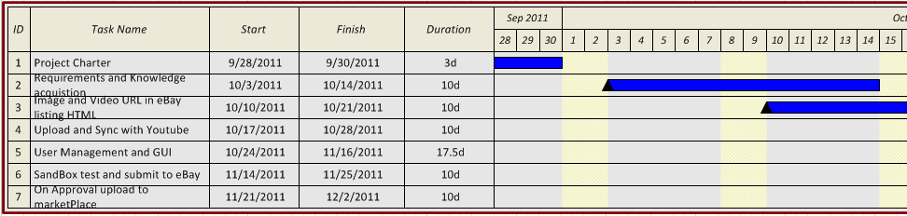

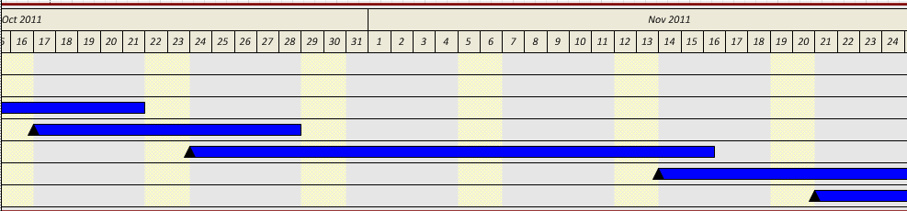

• Project Challenges – Once the application is constructed, it has to pass the eBay screening program.

• Project Finances – None.

• Project Estimated Completion Time – ~140hours.

• Project Status – We have server space in kurtzace.com, we are accepted into eBay developer’s program, commenced application construction.

• Project Contact(s) – Karan Bhandari, +1 302 438 2953.

[Karan.bhandari@student.csulb.edu](mailto:Karan.bhandari@student.csulb.edu)

**Event Name - ACM's Official Bang! Tournament (First)**

Event Manager(s) – Derrik Bulmer

Event Date(s) / Time(s) –

Elimination Rounds: Mon, Nov 21 4:00 – 7:00 P.M. and Tues, Nov 22nd 4:00 - 6:00 P.M.

Final Round: Tuesday Nov 22nd 6:00 P.M.

In ACM Room

Event Description –

Anyone can participate in a double-elimination tournament involving the card game Bang! by *DaVinci* games

Event Purpose –

“ACM's official card game” will have its first ever “official tournament”

Event Goals –

To show ACM's fun side, in that we have a card game to play

Event Requirements –

Rules – how to play

Scoring Guide – who wins or loses

Sign-up/Agreement forms – a sign-in sheet with a simple participant agreement statement

Bang! Cards – original and expansion sets

Record Spreadsheet – on computer spreadsheet program, double elimination brackets (or lose twice, you’re out!)

ACM Room – must be open an supervised

Event Team – Derrik Bulmer, Nate Pickrell, James Coolidge, Sal Liamas

Event Preparation Time line –

Special Bang! Events Committee: Thursday Nov 3rd at 12:00 P.M. - Done

AESB meeting: Friday Nov 4th at 1:00 P.M. – Done, announced personally

Sign-ups: Wednesday Nov 16th until Monday Nov 21st in ACM room

Tournament: Nov 21st-22nd 4 P.M. in ACM room

Event Challenges –

Involvement of members of non-CECS CSULB student organizations

Event Finances –

None Expected

Expected Attendance –

10 - 20 players

List of People Involved – Nate Pickrell, James Coolidge.

Expect to see many ACM members/officers, EAT members/officers, IEEE members/officers

Event Status – Draft.

Event Contact(s) – [events@csulb.acm.or](mailto:events@csulb.acm.or)

Project Name:   
 **Computer Game Modding Demo**

Project Manager:

Derrik Bulmer II

Project Definition:

To demonstrate how user-created content can be implemented in a computer game.

This is not a hack, exploit, or a plagiarism, and is therefore solely limited to user-created content that can be implemented legally, and only in a legally purchased copy of a computer game. No modifications to propriety software or hardware will be made, and no demonstrations of such will be attempted in this project. The demonstrations will only pertain to the method of implementing user-created content in a game that the developers allow user-created content to be implemented.

The game of choice for the workshop will be “Sid Meier’s Civilization IV” for the game developer officially permits user-created content being implemented in all their “Civilization” franchise games, and the ‘example mod’ will be able to show how extensive in which user-created content can be implemented in computer games besides the one in the demo (see the links under legal statements).

Project Scope:

Create an ‘example mod’ by the end of Spring 2011

‘Modding Workshop’ will be 8 weeks during Fall 2011.

‘Modding Workshop’ will meet once every week for approximately two hours.

See Addendum at end of project charter for definitions of ‘example mod’ and ‘Modding Workshop’

Project Goals:

Present an ‘example mod’ at during a demonstration to show how effective user-created content can be implemented in a legally purchased copy of a computer game.

Have a ‘modding workshop’ which demonstrates how user-created content can be implemented in legally purchased copy of a computer game.

Project Dependencies

Project team must have legally purchased copies of the computer game in order to demonstrate anything.

Room for workshop, which tutorials and demonstrations can be performed and supervised.

Open source user-created content is the only outside sources that can be used for demonstrations.

“Sid Meier’s Civilization” franchise is a prime example of a game franchise that permits the implementation of many different types and forms of user-created content in the computer games.

1. Free and open source SDK for “Civilization IV” was officially released
2. Official permission from Developer to modify ALL codes and to alter ALL graphics. The developer gives permission to upload user-created modifications as long as it is for non-profit and the user-created content is not claimed to be property of the one(s) responsible for creating and uploading the user-created content.

Project Team:

Derrik Bulmer II

Craig Thormodsen

Project Stakeholders

Project team will learn valuable skills.

Workshop participants will learn valuable skills also.

Official game producers that officially permit user-created content implementation in their games will benefit from increased interest in their product.

ACM will attract extra student interest in activities related to computer science and give its current members a fun activity.

Project Phases:

Phase-One: “Production of ‘example mod’”

The project team will create a ‘mod’ with non-copyrighted user-created content and the project manager will prepare tutorials. Project manager will demonstrate to ACM on how other students can have fun creating content for computer games.

Phase-Two: “The ACM ‘”Modding” Workshop”’

The project manager will prepare tutorials and demonstrations on how to add user-created content to a computer game in a group activity setting. Project team will attend workshops to assist in demonstrations.

Project Timeline

Phase-One should be finished by May 13th (one week before finals).

Phase-Two can resume the following semester, sometime after the Week of Welcome. Workshops are to be scheduled around that time.

Project Challenges

Preparing tutorials and demonstrations for creating and adding user-created content to computer games will be the projects managers’ main challenge.

Finishing the ‘example mod’ will be the project teams’ main challenge for Spring 2011.

Publicity for project, like flyers, and getting student involvement in the workshop demonstrations, will be the main challenge for Fall 2011.

*Addendum: Legality of modifying video games

Computer games, coding of computer games and modifications of computer games are the sole property of the producer of the computer game.

Not all games allow for modification to be made to their coding, while others only allow certain aspects of the game to be modified. Some game producers officially permit extensive user-created modifications to the game, and only the latter most will be considered to be used in any workshop here on campus (see legal statement link below).

The legality of modifying the games in this project have been thoroughly researched, and all games that are being considered have been permitted by the producers to be modified by 3rd parties as long as credit is given to the producer, and the mod needs the purchased computer game to run, cannot run as a stand-alone.

Legal statements:

<http://www.2kgames.com/civ4/blog_03.htm> link to official guarantee that modding Civilization IV is legal and completely permitted.

<http://www.civilization5.com/#/community/podcast_transcript_special> similar link to official guarantee that modding Civilization V is legal and completely permitted

*Addendum: Definitions:

A computer game ‘mod’ is anything that is user-created that is implemented in a computer game.

The ‘example mod’ may have video demonstrations that will be displayed during the ‘modding workshop’ with participants may or may not ask to participate or contribute in.

The ‘modding workshop’ will include tutorials and activities pertaining to the methods of creating user-created content for implementation in computer games (games that officially permit user-created content editing).

*Addendum: Project Liability

The project manager and all members of the project team assumes liability for any plagiarism or violations of any legal, moral, or ethical codes of any official game maker, Association of Computing Machinery, or California State University Long Beach. The project manager will obey any rule set forth by ACM, CSULB, and will purchase the legal copies of the games they wish to demonstrate in any college related event and will accept no monetary reward for the any aspect of the project.

Workshop participants are assumed to be innocent of any violation that occurs because of any member of the project team.

By the passing of this charter, the project team will provide the best work as possible to make the demonstration an enjoyable experience for all participants who wish to partake in activities.